
Explorihibit 4.0
HOSPITAL MANAGEMENT SYSTEM
Student IDs: 2311981443, 2311981477,2311981478, 2311981484,2311981503
Under the Supervision of : Dr. Shabaz Afzal



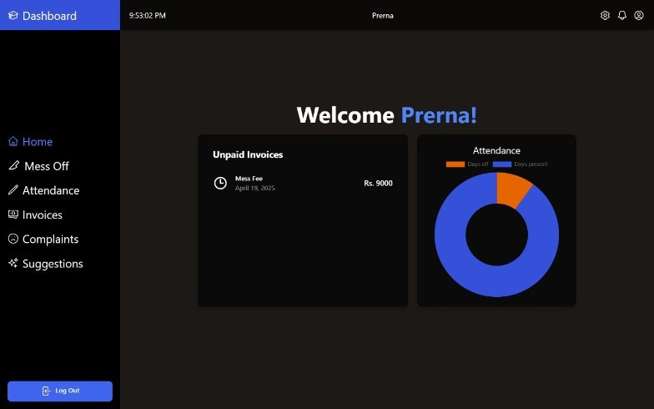
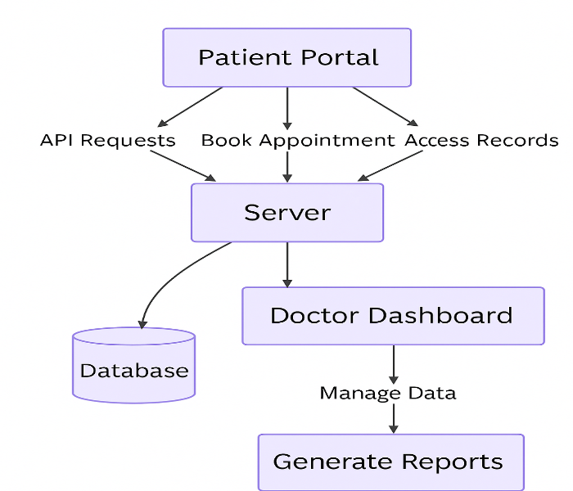



Impact & Results

• How it Works: Patients register, log in, book appointments, and access medical records; doctors and admins manage appointments, records, and hospital operations via a centralized dashboard.
• Its Limitations: Currently has limited analytics and lacks integration with external health systems or labs.
• Its Future Works: Implement mobile app support, integrate with wearable health devices, add cloud-based storage, and enable telemedicine features for remote consultations.

System Overview

Novelty / Innovation:
• Integrated patient, doctor, and appointment management in a single platform with real-time updates and centralized data handling.
• The system features a user-friendly interface with secure login, real-time medical record updates, analytics dashboard, and role-based access, streamlining hospital operations for administrators, doctors, and patients.
System Architecture

administrative workload and provides real-time access and transparency for patients, doctors, and hospital staff through a digital platform.
reduces
Processes
- Automating
involves time-consuming and error-prone tasks.
- To improve efficiency, as manual hospital
Motivation:

Manual hospital management is slow, error-prone, and hard to scale. It leads to delays, record mismanagement, and administrative overload. Our project offers a digital Hospital Management System to streamline patient registration, appointments, and records—ensuring faster, more accurate, and efficient healthcare operations.
Problem Statement:
Problem Overview

QR Code : Link to GitHub and Video

